

|  |  |
| --- | --- |
| **Brief document** | |
|  |  |
| 68 Lashes and nails  John Dao  Student ID: 13508159 |  |

Contents

1. Introduction 3

2. Target Audience 5

3. Goals and objectives: 5

4. Wireframe 6

5. Main key areas 7

6. Conclusion 14

7. Recommendations 14

8.Reference 15

### 1. Introduction

68 Lashes and nails background: the owner started as a trainee in a beauty salon. She is a hard worker who always aim for better service and quality. After 3 years in the industry, she decided to be self employed and started working from home. The business was booming to the point she spends more time working than before she resigned her previous job so she decided to open her own business. Although the opening date was delayed till August 2020 due to the global pandemic but she believed it allows her to get into the market better.

At the moment, we are working on our shopping cart function which is the third steps in Promotion phase. The function is expected to be completed before 25/11/2020 before we start research for paid traffic.

With 2 weeks before phase 3 and 4 weeks before the products launch, our marketing team is working hard to raise the customer’s awareness of the business and the webpage while also promoting though social media channel like Facebook and Instagram. Especially, with Christmas closing in, the business is aiming to reach out for all Nelson with promotion, deals, discount and sharing events. Our prototype also receives customer’s interest from begin of November until now.

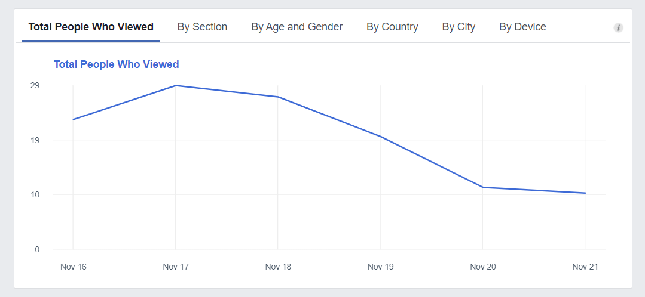

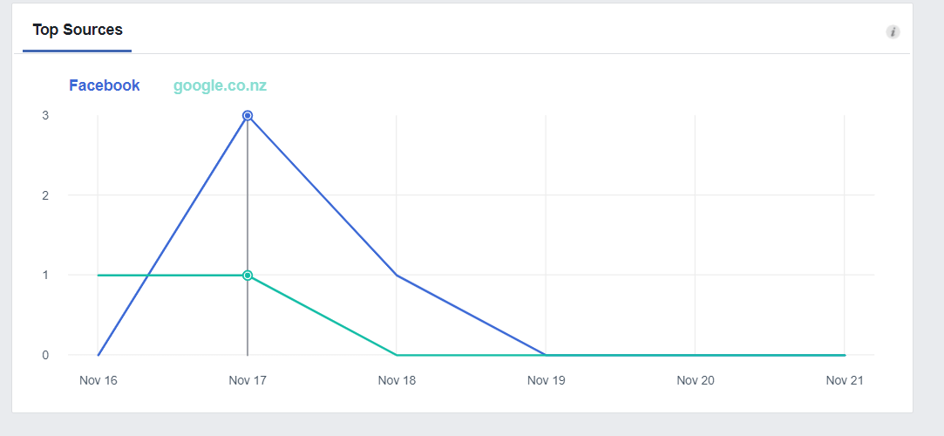

The company is a new start-up business with Nelson while there is many competitors. The owner believes there are still a big gap of in the market due to the influence of Covid-19 which leave many businesses in bad shape or financially deprived. Furthermore, there are a lack of professional and quality service within the current market which is one of the main goals of the business.

The website project will allow the business to gain professional online presence which will allow help with promoting business and reaching out to larger market share. The product is even more important for the business at the moment because of the changing in lifestyle due to global pandemic.

Product benefits:

Reach out to many customers as people is spending more time browsing the internet now than ever

Having a website give a professional outlook and increase business confidence and customers ‘s trust

Save money for ongoing promotion such as new paper posts, radio…

Website goals:

Attracting design and reinforcing business brand

Showcase the products and service available

Allow personal details for customisation

Dynamic webpage with cart, login and signup function

For the website project to be success, it would require new functions, features and stunning design to follow up with customers expectation especially within the current business’s industry. All those factors would require time and further research which could be exceed the budget limit.

### 2. Target Audience

* The target audience of the webpage would be female age range from 20 to 40 as they would be more mature and have stable source of income. As the business location is in the Nelson city centre, the focus would be customers who works in office environment and have internet access.
* The customers will be able to browse the website during their free time and make a book after checking all the information on the website. With the introduction of users details, customers can login and receive special deals and discount as a member. By proving free membership. The business can keep track of the customers base, users active and popular service
* Even without purchasing any products, the audiences still receive helpful information and have better understand of products and services available in the industry so that they can make confidence purchase decision.

### 3. Goals and objectives:

* Customers is presented with the business address and phone number which is helpful with booking or further enquires
* There are contact form and subscribe form for customers to gain further information about certain subject or leave a message for the business
* The cart function will allow the customer to pre-purchase the products or services and receive them in-store during their next visit. Online transaction will be a future goal due to the project budget
* The customers can check the products and services we offer online without travel to the store or call us. Some special deals and offer is also available but personal deal would need to receive though subscribe email.
* The website will allow the customers to get more information such as staff details, business history… while taking their private time. All the information should be available though the website or google without interfering the business with inquires calls.

### 4. Wireframe

### 5. Main key areas

#### 5.1 Competitors

* While we have many competitors around Nelson, after some search and observation, I believe they are lack in online presence and promotion activities. The Nails Garden would an example for the competitor as they are the closet business and belong in the same industry. Though research, I noted that there are no business website and only Facebook profile. Furthermore, there are lack of promotion activities as there are only daily post regarding their products.
* Although there a certain lack in some respects, The Nails Garden and other competitors was operated for much longer period and therefore their customer base is much higher than 68 Lashes and Nails.

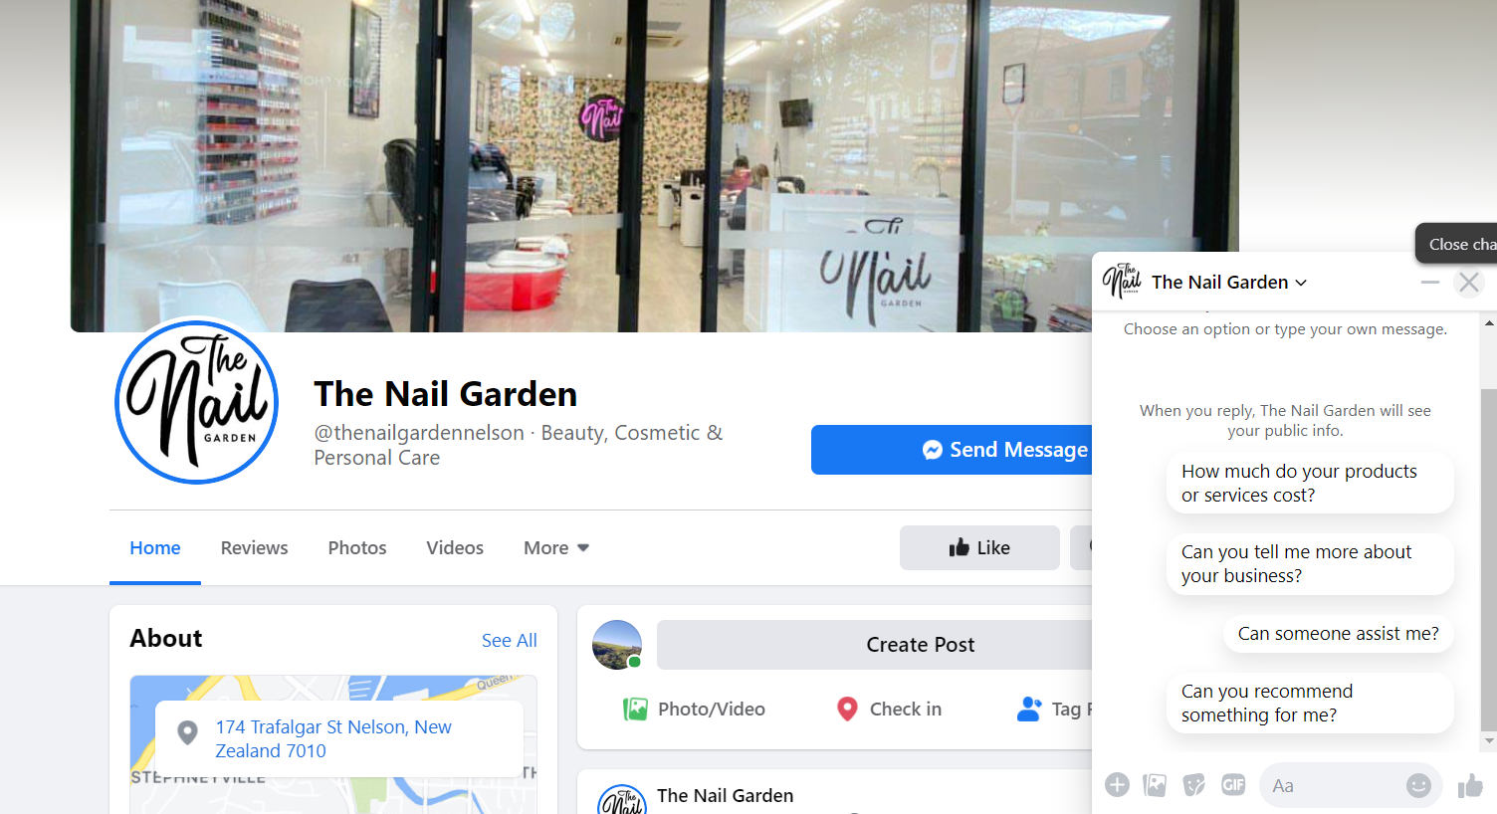

* For website, Wax and beauty lounge is one of the business’s competitors with a website. From my point of view, the website is nicely design and support online booking system which allow external host booking and payment system. Furthermore, all the services is presented neatly with full details regarding their products and services. I would like the deploy an online booking system to help the business reduce the stress of keeping the booking records.

<https://www.waxandbeautylounge.co.nz/>

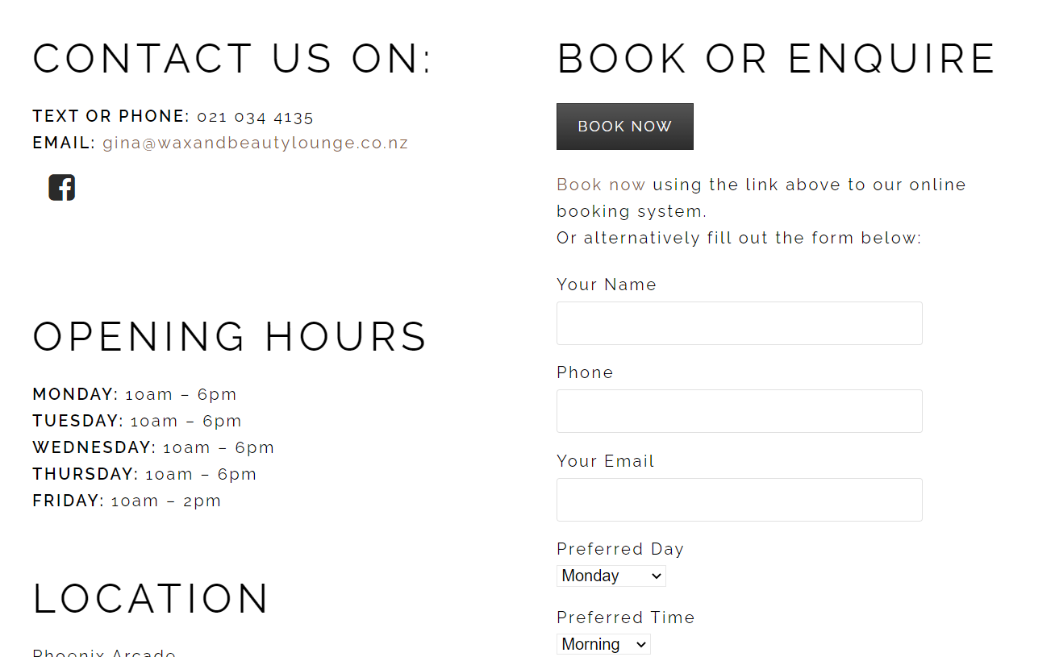

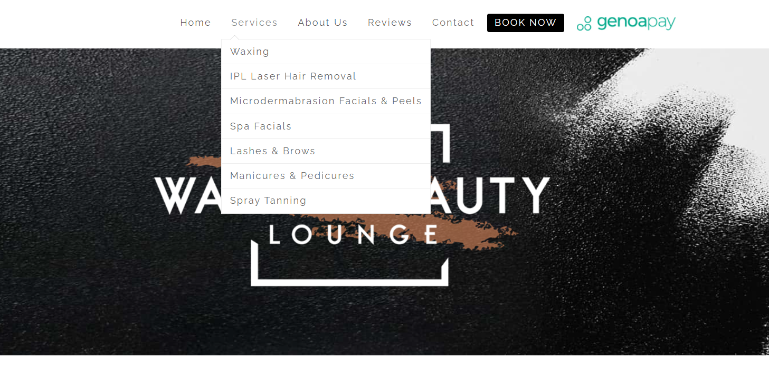

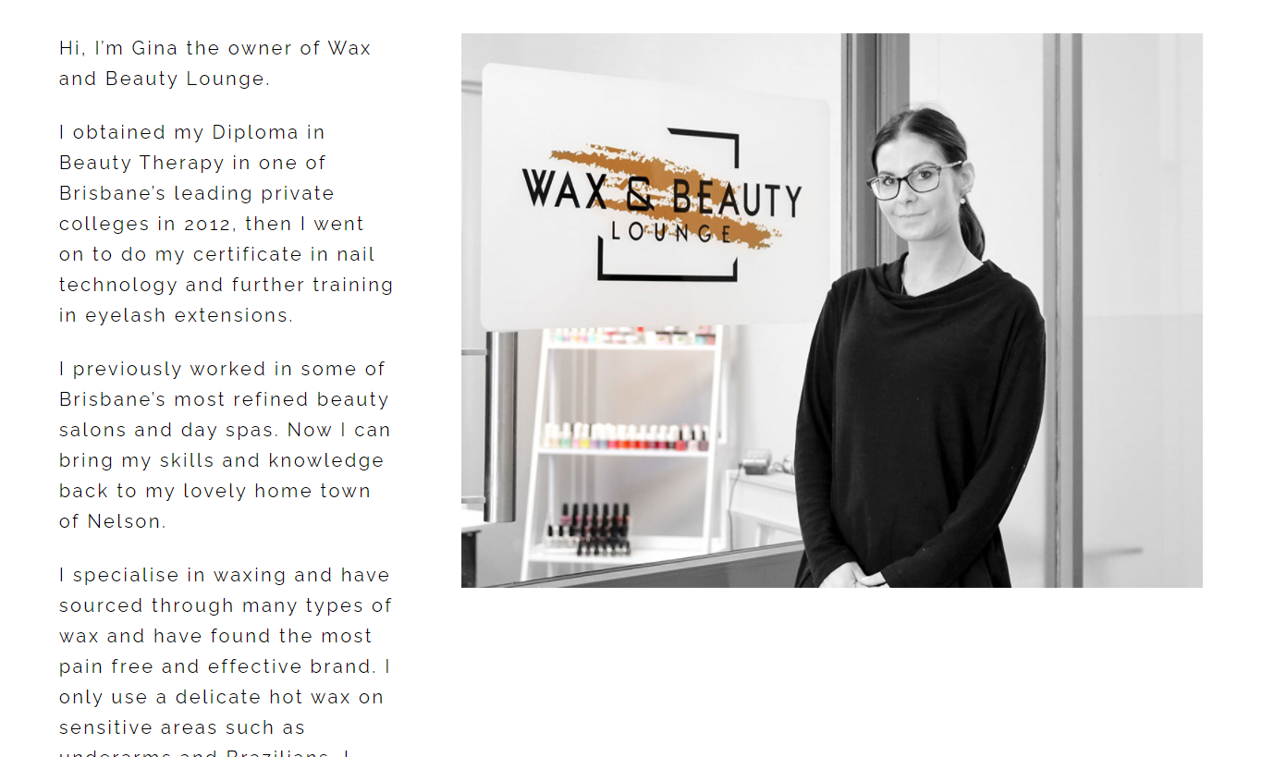



#### 5.2 Project Management and Timeline

Road Map

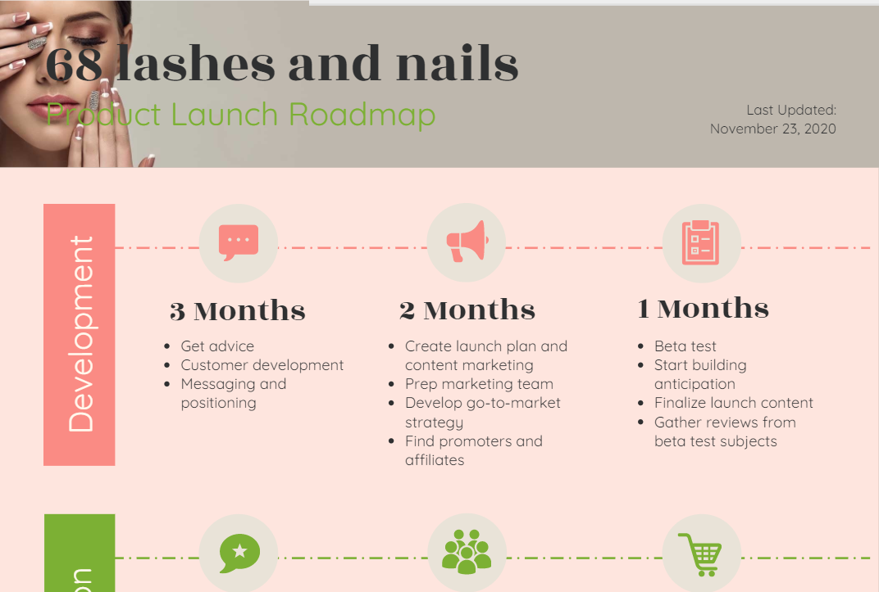 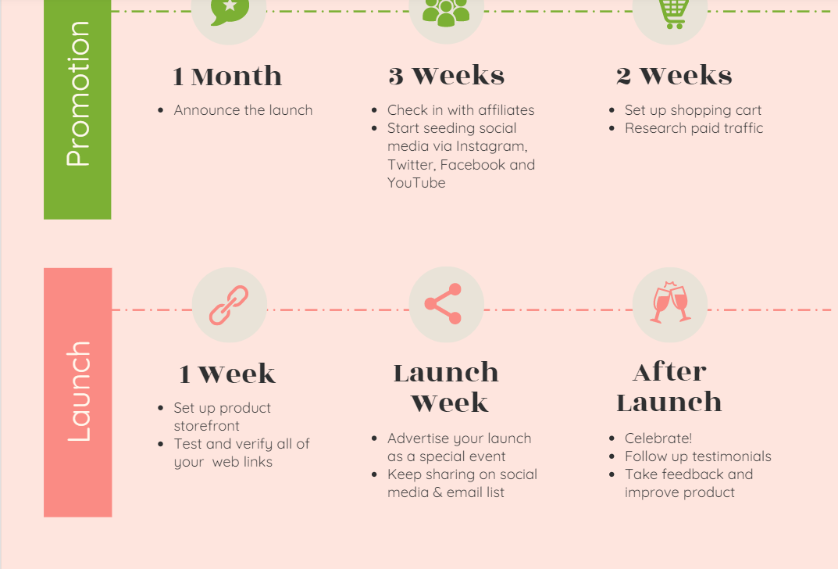

* There are currently 1 person working on the webpage project which is me. I am the main developer at the moment who is responsible for developing the webpage full time. In the future if the business hiring more people, the one with most experience will be team leader when there are more team members joining in.
* The project is intended to go live on 21 December 2020 according to the product Roadmap.
* It is intended to match the Christmas promotion active of the business which involve drawing a winner event on Facebook. By announcing the winner on the webpage, it will increase the traffic on the website and allow people to be aware of all the function which will be available

#### 5.3 Budget

* The Budget for the webpage is $5000
* For the first phase of the project will amount $3000
* The second phase will allow up to $1500
* The last phase will be $500
* The main cost will be labour cost which is for the web-developing process and about $500 to $1000 for hosting the website and possibly working with external host system such as booking, payment …

#### 5.4 Technical

* Currently there are a prototype website running in place to test the webpage performance and increase the website online presence. The prototype website address is 68lashesandnails.com.
* For the dynamic features, Firebase is deployed to support the function of storing subscribed email and users’ personal details linking with personal cart information.
* The prototype is running fine and gaining attention from customers. At the moment, our aim is Nelson’s population so only English will be available for our webstore, depending on demographic and business development other language such as Chinese, Spanish will be taken in consideration.
* The website is deployed though GitHub page service which offer free hosting and allow us to reduce the project cost. While only one GitHub page is allowed, we can work on the website in different repository within the same GitHub account. By doing so we can limit the access of users on constructing pages.
* In the third phase, with the login/signup function, users will be allowed to customise their account and save the cart for favourite or interested items which allowed them to be paid for the cart instore. In the future, external payment system is presented as a great option to allow further income for the business

#### 5.5. SEO and Digital marketing

* By using the Google business feature combine with linking the Facebook page to our website, the traffic to the prototype webpage is increasing which allow the final product to gain more attention.
* Moreover, we allow include all the key words to improve the searching result and allow google crawler find our webpage better.
* Top 7 key words or search phase for us:

1. Nails
2. Lashes
3. 68 Lashes
4. 50 Bridge street
5. eyelashes extension
6. Nails design
7. Beauty service

#### 5.6 Contact Information

Junior Web-developer: John Dao

Email: [john.d1729@gmail.com](mailto:john.d1729@gmail.com)

Owner: Trang Doan

Email: [68lashesandnails@gmail.com](mailto:68lashesandnails@gmail.com)

### 6. Conclusion

The final webpage progress is on track with Roadmap planning phase which will allow the business to improve their promotion for the summer period and increase the online presence and competition strength. The webpage will be designed to provide the basic functions of presenting the products and business to customers while also allow dynamic features like storing data and allow user customisation.

### 7. Recommendations

For future improvement, I recommending the business to employee a web-designer at the same time as I would reduce the work load for the web-developer and allow each team member to work in their expertise field and produce the best result. Another option would be Content management system (CMS) such as Wix or WordPress. By Using CMS, the website can be developed at much lower price and in shorter timeframe. Moreover when the products is finished, the owner can pick up the management of the website as CMS allow GUI control and decrease the cost for maintaining for webpage.

### 8.Reference

“Authenticate with Firebase Using Email Link in JavaScript.” Accessed November 23, 2020. <https://firebase.google.com/docs/auth/web/email-link-auth>.

“Add Firebase to Your JavaScript Project.” Accessed November 23, 2020. <https://firebase.google.com/docs/web/setup>.

“(7) Beauty4all.Nelson | Facebook.” Accessed November 23, 2020. <https://www.facebook.com/nelson.browsandbeauty.sophie/>.

“How To Create a Checkout Form with CSS.” Accessed November 23, 2020. <https://www.w3schools.com/howto/howto_css_checkout_form.asp>.

Wax & Beauty Lounge. “Wax & Beauty Lounge, Phoenix Arcade, 41 Montgomery Square, Nelson.” Accessed November 23, 2020. <https://www.waxandbeautylounge.co.nz/about/>.

Kinsta. “What Is A Content Management System (CMS)?” Accessed November 23, 2020. <https://kinsta.com/knowledgebase/content-management-system/>.

Optimizely. “Content Management System.” Accessed November 23, 2020. <https://www.optimizely.com/anz/optimization-glossary/content-management-system/>.